Certification Steps Overview
Revised: 5/20/2020
Certification is accomplished through manufacturer registration, pre-application, application, and post-application activities. Each stage requires specific information, and submissions during the Application stage are reviewed in several steps culminating in a final decision. Additional detail is given below.

MANUFACTURER REGISTRATION
Manufacturers wishing to certify for the first time must register with CARB and must submit any changes to registration items thereafter. Registration requirements are outlined in the New Manufacturers Checklist. Each registered manufacturer is assigned a staff engineer to coordinate with in regards to certification, including applications, meetings, and questions. CARB is available for in-person meetings, teleconferences, and webcast meetings.

PRE-APPLICATION STEPS
Manufacturers are strongly encouraged to hold annual Certification Preview meetings to preview certification plans over the subsequent 1-3 years. This meeting should introduce any new durability testing programs, carryover deterioration factors (DF's), and auxiliary emission control devices (AECD's), and follow-up communication and meetings will be arranged to review these items in detail. Reviews of durability programs, carry-over DF's, and AECD declarations are time-consuming, and the loss of much time can be avoided by submitting these items in advance of the associated applications and durability testing using the DF Carry-Across Worksheet and AECD Descriptions templates.

APPLICATION STEPS
Submission of Applications
All applications must be submitted to the Document Management System (DMS) and the E-Cert Certification System (E-Cert), once operational. Information submitted via other means is viewed as informal only. The data required in each application is listed in the On-Road Certification Checklist and Off-Road Compression-Ignition Certification Checklist.
Carryover Applications
Carryover applications are reviewed normally, except that Full and Partial Carryovers are processed in an expedited manner. For more information, see the Streamlined Carryover Template. Each carryover application is checked to verify that it is indeed a carryover of a previously-approved application.

Preliminary Staff Review
Within 30 days of submission, CARB will notify the manufacturer that the application has been received and whether the information submitted is sufficient to proceed to a full, detailed review. It is expected that an application will be entirely complete at the time of initial submission, but there are scenarios when specific items may be submitted once available, e.g. OBD approvals. In all cases, staff will evaluate whether the quantity and quality of information submitted merits a full review and whether it is likely that the manufacturer will submit the remaining data in a reasonable amount of time during the review process.
Full Staff Review
When CARB determines that an application is sufficiently complete, the manufacturer will be notified that the application is "Accepted for Filing", and a detailed review will be initiated. CARB will certify the completeness and content of the application, including engine and vehicle family names, weight classes, duty cycles, emission control systems, test engines and vehicles, emissions testing and durability data, pollutant certification levels, applicable emissions standards, emissions labeling and warranty information, and so forth. Certification proceeds in parallel with On-Board Diagnostics (OBD) review - applications may be submitted before OBD approval is granted, but may not be approved until OBD approval is verified. Manufacturers may update applications during this review, and must do so if any changes occur to the design or production process. CARB will provide substantive feedback to the manufacturer about what further information is needed or provide notification of completed review within 30 days since initiating Full Staff Review or since the last meaningful application update.
Peer and Management Review
If the full review completes successfully, the application will be marked as "Reviewed" and will then be reviewed by another staff engineer and by management. This review will verify the determination of the assigned staff engineer, and usually completes in a short time; though, it is impossible to predict how long in advance. Updates or additions to the application are disallowed during this stage unless specifically asked to do so by CARB staff; this restriction ensures that the version of the application reviewed by management matches the version present in the submittal system(s).
Final Decision
When all review is complete, a final decision will be made - to approve or disapprove. Approvals may be issued an Executive Order, as needed.

POST-APPLICATION STEPS
Running Changes and Field Fixes
Running changes and field fixes are treated in the same manner as described above, with the exception that running changes and field fixes which incorporate changes to information not included on the pertinent Executive Order will likely not require a new Executive Order be issued.
End-of-Year Reports
Manufacturers must submit annual production and ABT reports, if applicable, after the end of each production model year.

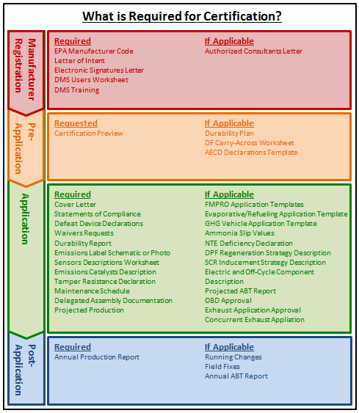

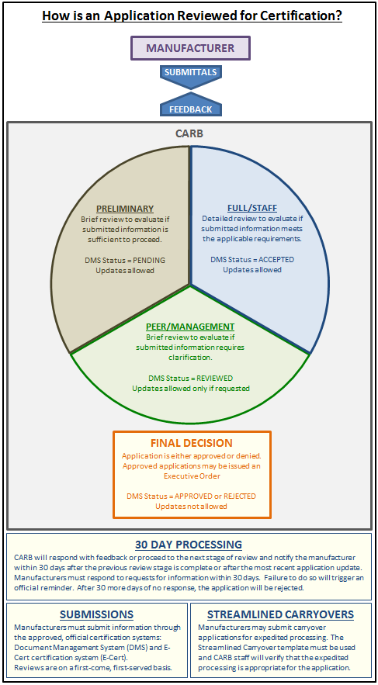
Frequently Asked Questions

Q: How is manufacturer registration initiated? To whom must correspondence be addressed?
A: Please communicate with the supervisor of the On-Road Heavy-Duty Certification Program section.

Q: Is there a template for Certification Preview presentations?
A: No. Certification Preview presentations should focus on important details. Manufacturers should come prepared for in-depth questions, especially for requests for new products, testing cycles, consideration for special situations, etc. Manufacturers should be careful in what is taken for granted when composing the Certification Preview presentation.

Q: How much earlier than the application must Durability Plan, DF Carry-Across, and AECD documents be submitted?
A: The time needed for review of these documents will vary with each situation. It is recommended that manufacturers briefly introduce upcoming products, the durability plans, DF carry-across requests, and AECD’s that these products will utilize, and the anticipated certification schedule. CARB will then be able to indicate how soon these items should be submitted in order to meet the manufacturer’s schedule.

Q: Why is certain information required in applications that may not be applicable, e.g. waivers requests?
A: In order to have manufacturers explicitly declare whether certain items are being utilized and to describe them if used, it is required that Defeat Device Declarations, Waivers Requests, Durability Reports, Sensors Descriptions, Emissions Catalysts Descriptions, Tamper Resistance Declarations, and Delegated Assembly Declarations be included in applications. In the case when items aren’t utilized, a statement to that effect is sufficient. For example, a manufacturer may simply state that Delegated Assembly is not being used. Manufacturers are encouraged to refrain from using the phrase ‘Not Applicable’ if the phrase ‘is not being utilized’ is more appropriate; there are regulatory provisions which apply to applications but go unused by the choice of the manufacturer.

Q: Are there templates for items submitted in the Application stage?
A: Yes. There templates for AECD Declarations, DF Carry-Across, Sensors Descriptions, FMPRO Applications, Evaporative/Refueling Applications, GHG Vehicle Applications, and the Projected ABT Report. See the On-Road Certification Checklist for more information.

